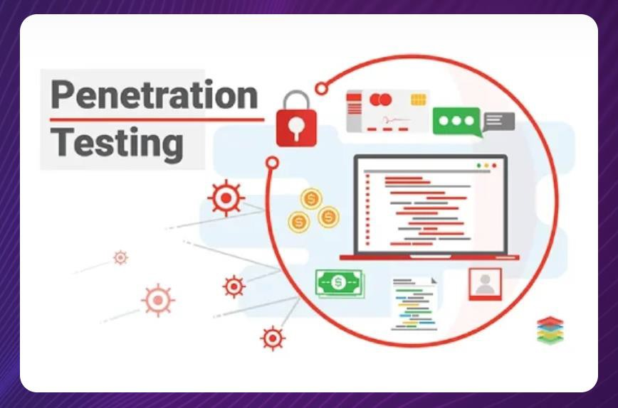
Presented by
Professor Dr. Mohammed Shafiul Alam Khan IIT, DU

Penetration Testing / Ethical Hacking
- A proactive cybersecurity practice
- A simulated cyberattack performed to evaluate the security of a system,
network, or application by identifying vulnerabilities that could be exploited.

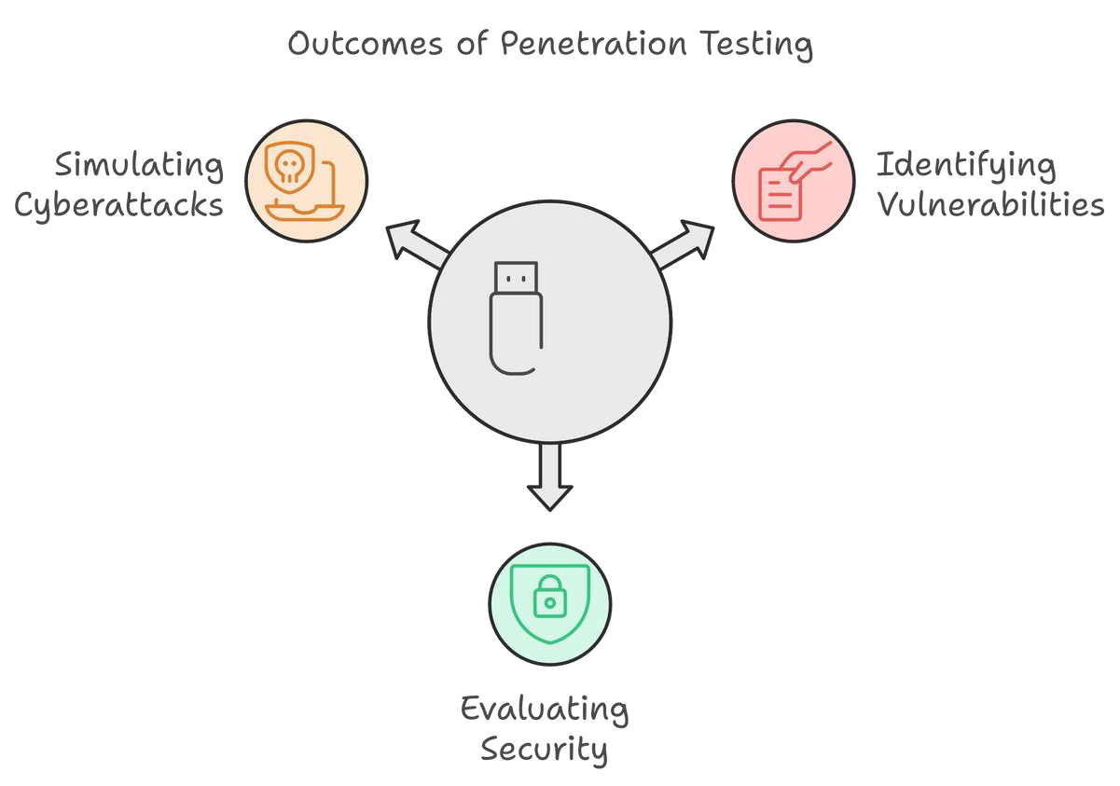Purpose
- Assessing Compliance
- Assess system security, identify weak points, prevent real attacks
- To strengthen security measures

PEN TESTING

Common Terminologies
  - Vulnerability: A weakness in a system that attackers can exploit to compromise security.
  - Exploit: A method or code used to take advantage of a vulnerability in a system.
  - Payload: The part of an exploit that performs the malicious action once the system is compromised.
  - Privilege Escalation: Gaining unauthorized higher-level access to a system.
  - Attack Vector: The path or method used to exploit a vulnerability (e.g., phishing).
  - Zero-Day: A newly discovered vulnerability without a vendor patch available.
  - Post-Exploitation: Actions taken after exploiting a system, like data extraction or maintaining access.

PEN TESTING

How it Works
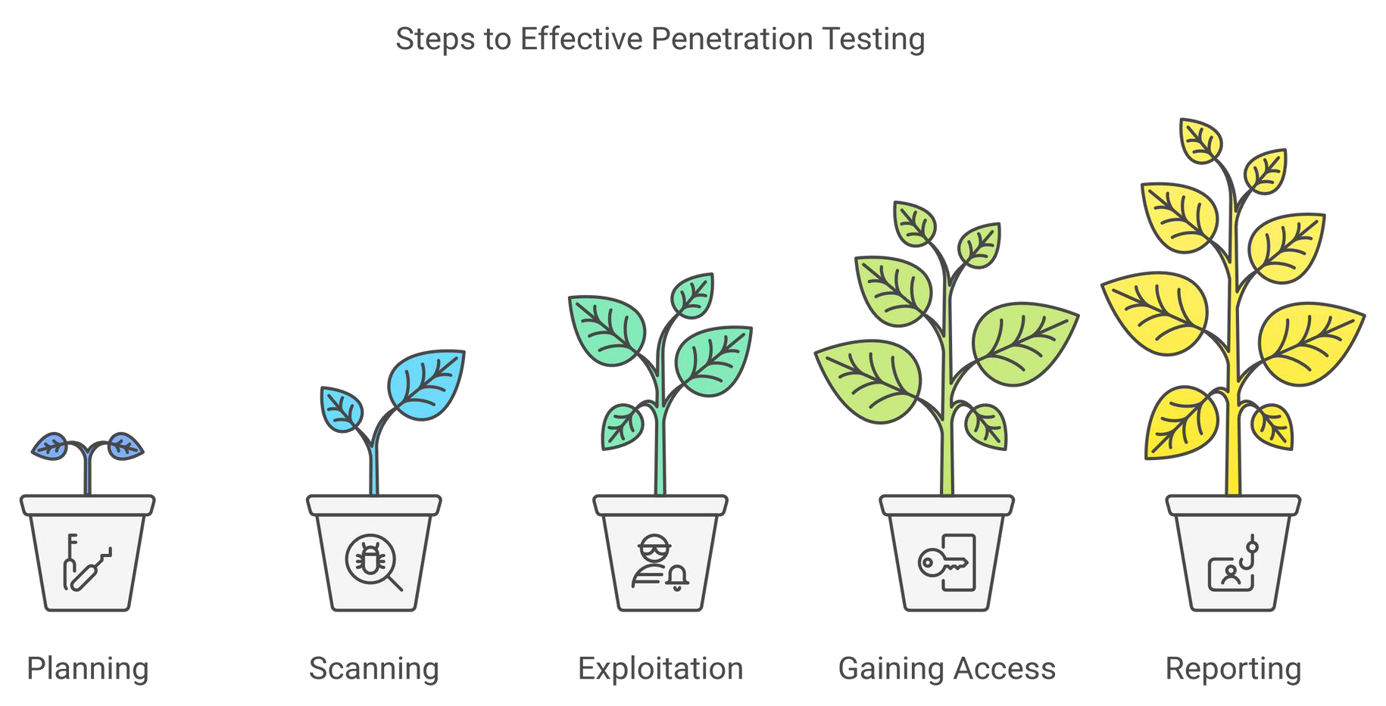

PEN TESTING

Steps
- Reconnaissance (Plan): Gather information about the target system using open-source intelligence and other techniques
- Scan: Scanning phase involves actively probing the system for vulnerabilities using automated tools and manual techniques
- Exploit: Attempt to exploit vulnerabilities in a controlled manner to assess the impact of a potential attack. It mimics the tactics used by real attackers to gain unauthorized access, escalate privileges, exfiltrate data, or disrupt operations.
- Report: Analyze findings and compile a comprehensive report that outlines the identified security weaknesses, their potential impact, and recommended remediation measures which is used to patch vulnerabilities, improve security policies, and enhance defense mechanisms.

- Start by defining the aim and scope of a test.
- To better understand the target, one should understand how it functions and any possible weaknesses.
Plan
Scan
Gain Access
Maintain Access
Analyse
- Locate vulnerabilities in the target application using pen- testing strategies, i.e. cross- site scripting and SQL injection.
- Exploited vulnerabilities
- Sensitive data accessed

  - Use static or dynamic analysis to scan the network.
  - Inform pen-testers regarding the application responds to various threats.
  - Check the ability of a cybercriminal to maintain a persistent presence through an exploited vulnerability

PEN TESTING

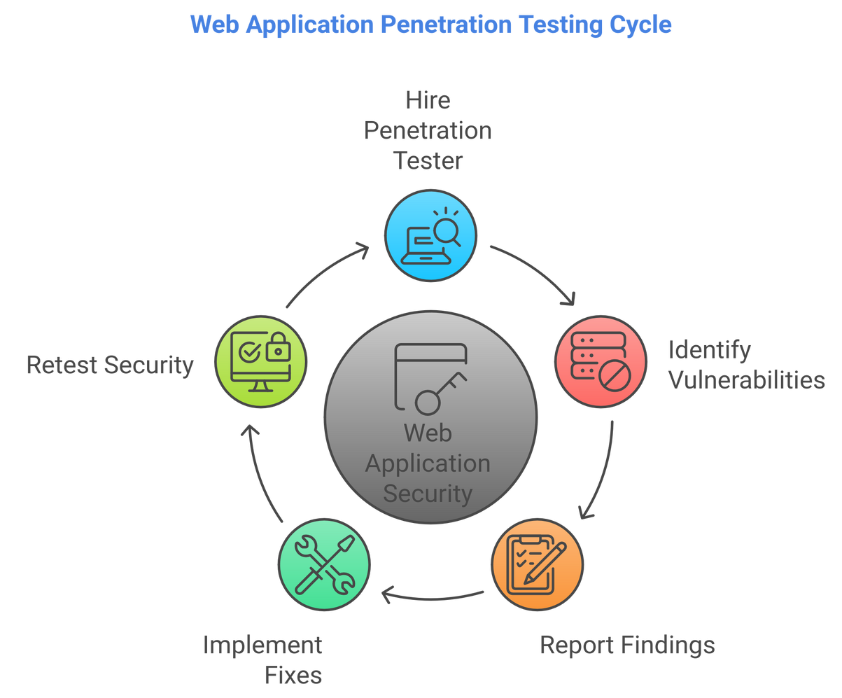Example

A company has an e- commerce website and wants to ensure it’s secure from potential cyberattacks. They hire a penetration tester to assess its vulnerabilities.

PEN TESTING

Example

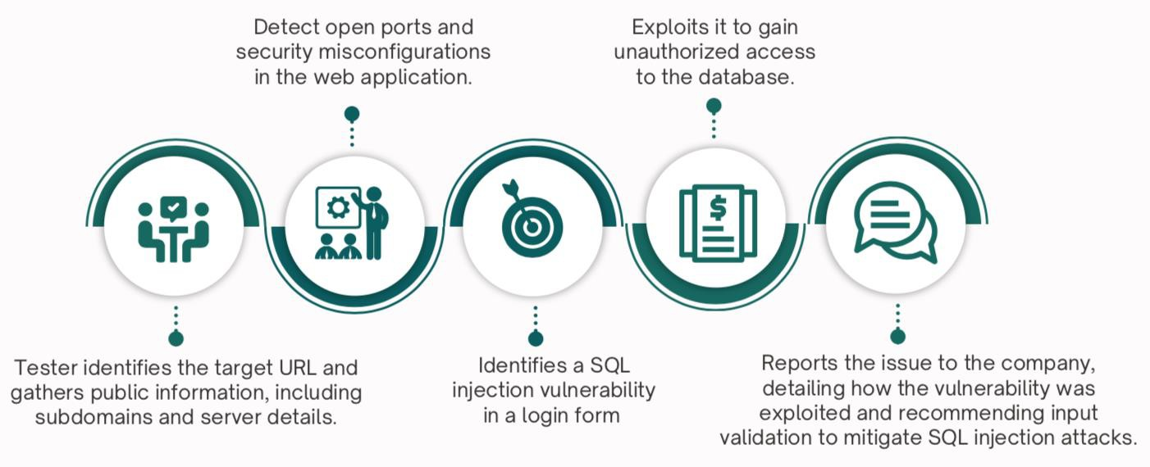

PEN TESTING

Types of Pen Testing

⌘ Black Box Testing:
⌘ Tester has no prior knowledge of the system.
⌘ Mimics an external attack.

⌘ White Box Testing:
⌘ Tester has full knowledge of the system (e.g., source code, architecture).
⌘ Mimics an internal attack.

⌘ Grey Box Testing:
⌘ Partial knowledge of the system.
⌘ Simulates an insider threat with limited access.

PEN TESTING

Issues Addressed

- Uncovered Vulnerabilities: Identifying hidden flaws in systems, applications, or networks
- Misconfigurations: Misconfigured security settings that expose systems to unauthorized access or attacks.
- Outdated Systems and Software: Older software or systems that lack the latest security
patches
- Human Errors: Errors by users or administrators that inadvertently create security risks.
- Lack of Real-World Attack Simulation: Organizations often struggle to understand how an attacker could exploit their systems.
- Non-Compliance with Security Standards: Organizations may not meet regulatory
requirements for security testing.

PEN TESTING

Impacts on Security

  - 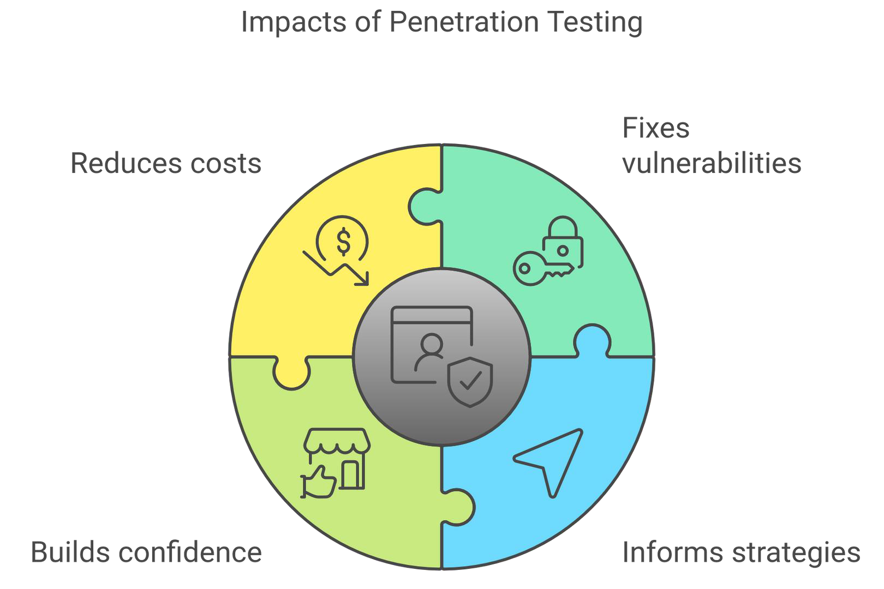Proactive Risk Mitigation
  - Strengthened Regulatory Compliance
  - Boosted Security Awareness
  - Better Security Posture
  - Reduced Financial and Reputational Risk
  - Builds Customer’s Trust and Assurance

PEN TESTING

Common Challenges

    - Scope Creep: Uncontrolled growth of scope
    - Lack of Communication and Collaboration

    - Limited time and resources

    - False Positives and Negatives
    - Evolving Threat Landscape
    - Resistance from IT Teams

PEN TESTING

Common Cyber Attacks

- Phishing: Deceptive emails or messages designed to trick individuals into revealing sensitive information like passwords or credit card numbers.
- Denial of Service (DoS): Overloading a system, network, or website with traffic to make it unavailable to users.
- Man-in-the-Middle (MITM): Intercepting and altering communications between two parties without their knowledge.
- Ransomware: Malware that encrypts a victim’s data and demands payment for its release.

PEN TESTING

Common Web Attacks
- SQL Injection: Exploiting input fields to inject malicious SQL queries, enabling unauthorized database access or manipulation.
- XSS (Cross-Site Scripting): Injecting malicious scripts into web pages viewed by users, leading to
data theft or session hijacking.
- Broken Authentication: Flaws in authentication processes that allow attackers to compromise user credentials or sessions.
- Security Misconfiguration: Improperly configured security settings that expose systems to potential
attacks.
- Cross-Side Request Forgery (CSRF): Exploit to make malicious requests to internal or external resources.

PEN TESTING

Common Network Attacks
- Port Scanning: Probing a network to discover open ports and identify running services for potential exploitation.
- Eavesdropping: Intercepting network communications to capture sensitive data like passwords or
messages.
- Packet Sniffing: Capturing and analyzing network traffic to gather information or exploit vulnerabilities.
- Replay Attacks: Capturing and reusing legitimate network data (e.g., authentication tokens) to
gain unauthorized access.
- IP Spoofing: Faking an IP address to impersonate a trusted system and bypass security measures.
- DNS Poisoning: Manipulating DNS records to redirect users to malicious websites or intercept
traffic.

PEN TESTING

Common Tools
Relies on a variety of tools to identify, exploit, and assess security vulnerabilities.

- Shodan
- Harvester
- Maltego (extract publicly available data, such as domain names, email addresses, IP addresses, and subdomains.
Reconnaissance
- Nmap (network scanning tool)
- Nessus and OpenVAS (explore security weaknesses, misconfigurations, and outdated software versions)
Vulnerability Scanners
- Metasploit (comprehensive database of known exploits)
- SQLmap (SQL injection vulnerabilities)
Exploitation Frameworks

PEN TESTING

Common Tools

- John the Ripper
- Hashcat
- Hydra
Password Attack Tools
- Mimikatz
- Empire
Post-exploitation Tools
- Burp Suite,
- OWASP ZAP
Web Vulnerability Scanners

PEN TESTING

Common Tools

Network Tools

- Wireshark
- Aircrack-ng
Mobile Testing Tools

- MobSF
- Drozer

PEN TESTING

Common Industry Certifications

- CompTIA PenTest+
- CEH (Certified Ethical Hacker)
- OSCP (Offensive Security Certified Professional)
- GIAC GPEN (Certified Penetration Tester)
- OSWE (Offensive Security Web Expert)
- GXPN (GIAC Exploit Researcher and Advanced Penetration Tester)



THANK YOU!

